How to Create a Work Breakdown Structure
Creating a work breakdown structure (WBS) helps you be both comprehensive and specific when managing a project: Thinking in detail is critical when planning your project, but you also need to consider the big picture. If you fail to identify a major part of your project’s work, you won’t have the chance to detail it. A work breakdown structure is key.
The diagram here shows that the entire project, represented as a Level 1 component, can be subdivided into Level 2 components, and some or all Level 2 components can be subdivided into Level 3 components.
You can continue to subdivide all the components in the same manner until you reach a point at which you think the components you defined are sufficiently detailed for planning and management purposes. At this point, you now have Level “n” components, where n is the number of the lowest-level component in a particular WBS branch. Level “n” components are called work packages.
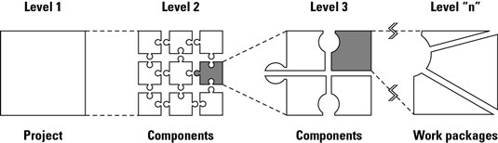
Develop a work breakdown structure to determine the hierarchy of a project.
Suppose you’re responsible for creating and presenting a new training program for your organization. To get started, you’d develop a WBS for this project as follows:
- Determine the major deliverables or products to be produced.
Ask yourself, “What major intermediate or final products or deliverables must be produced to achieve the project’s objectives?”
You may identify the following items:
  - Training program needs statement
  - Training program design
  - Participant notebooks
  - Trained instructor
  - Program testing
  - Training program presentation
- Divide each of these major deliverables into its component deliverables in the same manner.
Choose any one of these deliverables to begin with. Suppose you chooseTraining program needs statement.
Ask, “What intermediate deliverables must I have so I can create the needs statement?”
You may determine that you require the following:
  - Interviews of potential participants
  - A review of materials discussing the needs for the program
  - A report summarizing the needs this program will address
- Divide each of these work pieces into its component parts.
Suppose you choose to start with Interviews of potential participants.
Ask, “What deliverables must I have to complete these interviews?”
You may decide that you have to produce the following deliverables:
  - Selected interviewees
  - Interview questionnaire
  - Interview schedule
  - Completed interviews
  - Report of interview findings

